**Shrimati Indira Gandhi College**

**Department of Mathematics**

**NAAN MUDHALVAN PROJECT REPORT**

**Project partner: Smart internz**

**Project by: Data literacy with tableau**

**Class: III B.Sc (MATHEMATICS)**

**Team ID:NM2023TMID04614**

**Subscriber’s Galore: Exploring World’s Top Youtube Channels**

**INTRODUCTION**

**Overview:**

As of my last update in September 2021, YouTube has been a dominant force in online entertainment for years, serving as a platform for creators, influencers, musicians, educators, and more. Over the years, several channels have risen to prominence, amassing millions, and in some cases, over a hundred million subscribers. Here's a brief overview of some of the world's top YouTube channels.

**Purpose:**

The primary objective of "Subscribes Galore: Exploring World's Top YouTube Channels" is to analyze and understand the meteoric rise and sustained popularity of the platform's most subscribed-to channels. By diving deep into the content, strategies, and appeal of these channels, we aim to:

1. Highlight the Diversity
2. Understand Viewer Engagement
3. Assess Global Impact
4. Trace Evolutionary Trends
5. Provide Insights

**PROBLEM DEFINITION AND DESIGN THINKING**

EMPATHY MAP:

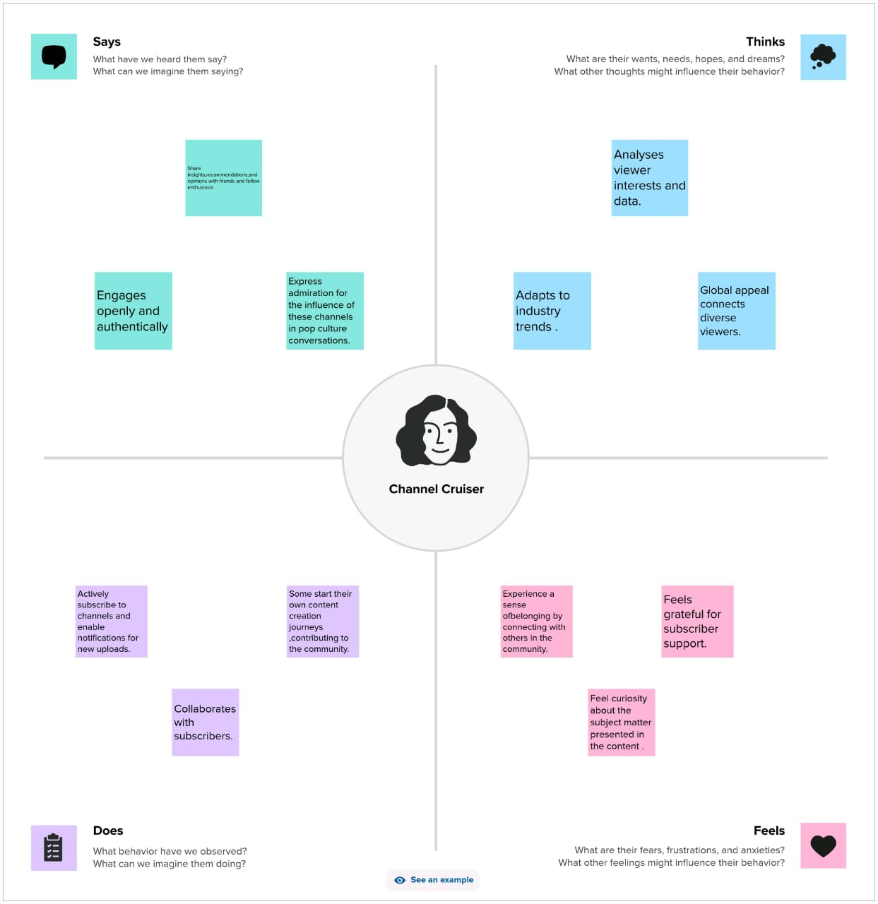

BRAINSTROMING MAP:

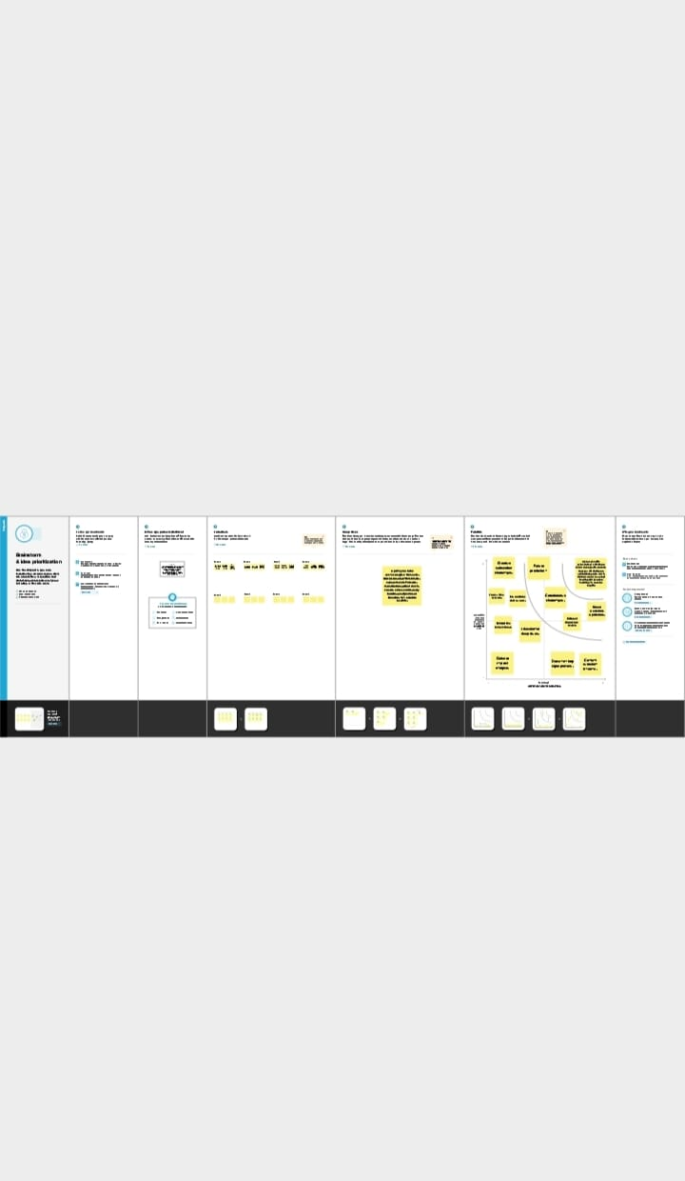

**RESULT**

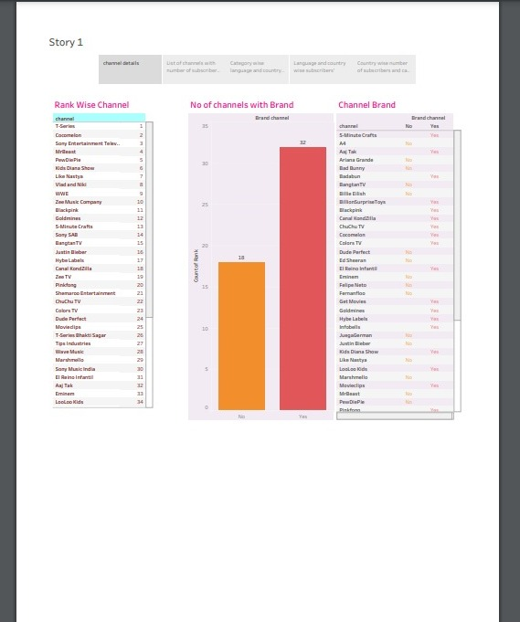

**ADVANTAGES**

Diverse Content: Top channels cover a wide range of topics from music, education, entertainment, DIY, to vlogging. This showcases the platform's capability to cater to varied interests.

Economic Boost: Successful channels often generate significant ad revenue, not just for the creators, but also for YouTube and its parent company, Google.

Global Influence: Popular channels can influence global trends, popularize cultures, and even set industry standards.

**DISADVANTAGES**

Over-Saturation: With many aiming for the top, the platform can become oversaturated, making it harder for new creators to get noticed.

Clickbait: In the race for views and subscribers, some channels resort to misleading thumbnails and titles, also known as clickbait.

Pressure to Produce: To remain on top, creators often face pressure to consistently produce high-quality content, which can lead to burnout.

**CONCLUSION**

In the vast digital landscape of YouTube, the top channels stand as testaments to the platform's global reach and the evolving dynamics of content consumption. These channels, diverse in nature, spanning from music and entertainment to DIY and education, not only reflect the varied interests of viewers but also the democratization of content creation. They've broken traditional barriers, bringing forth global trends, influencing cultures, and even setting new industry standards.

However, with great influence comes inherent challenges. The race to the top can sometimes overshadow originality, pushing creators into a relentless cycle of production and leading to issues like content saturation, clickbait, and immense pressure. The very essence of being at the top means being under the microscope, facing intense scrutiny from millions.

Yet, despite these challenges, the success stories of these top channels inspire countless others to share their voices, stories, and talents. The world of YouTube is ever-evolving, and while the platform's giants enjoy their moment in the spotlight, the next generation of creators is already emerging, ready to shape the future of digital content. In conclusion, YouTube's top channels highlight the platform's immense potential, its challenges, and the ever-changing nature of online content.

**FUTURE SCOPE**

The future scope for a Subscribers Gallery to help a YouTube channel become one of the world's top channels involves a combination of factors and strategies:

1. *Content Quality:* Producing high-quality, engaging, and unique content is essential. Focus on creating content that resonates with your target audience and keeps them coming back for more.

2. *Consistency:* Regular uploads and a consistent posting schedule are crucial for retaining and growing your subscriber base.

3. *Audience Engagement:* Interact with your audience through comments, live streams, and social media. Building a strong community around your channel can be a significant asset.

4. *Search Engine Optimization (SEO):* Optimize your video titles, descriptions, and tags to increase visibility in YouTube's search results.

5. *Collaborations:* Collaborating with other YouTubers can introduce your channel to new audiences and help you grow faster.

6. *Social Media Promotion:* Leverage other social media platforms to promote your YouTube channel and connect with a broader audience.

7. *Adapt to Trends:* Stay updated with current trends and adapt your content to cater to what's popular within your niche.

8. *Analytics:* Use YouTube Analytics to understand your audience's preferences and adjust your content accordingly.

9. *Monetization: * Explore various monetization options on YouTube, such as ads, merchandise, sponsorships, and Patreon to generate revenue.

10. *Long-Term Vision: * Building a top YouTube channel takes time and dedication. Have a long

**APPENDIX**

SOURCE CODE:

https://public.tableau.com/app/profile/dhanuja.v/vizzes